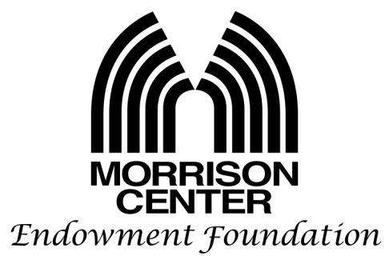

The Morrison Center Endowment Foundation’s goal is to impact quality art performances at the Velma V. Morrison Center for the Performing Arts. We do this by subsidizing production costs for Idaho’s local performing arts groups. Before filling out your request, read our granting procedure and note the list of items needed. Please provide five copies of the requested items to help our grant committee make an informed decision. Be aware, requests to fundraise for entities other than the group submitting the grant application will not be considered.
Granting Procedures:
- Grants will only be given for performances in the Velma V. Morrison Center. For more information on current Morrison Center rental charges contact Laura Kendall, Executive Director of the Center (lkendall@boisestate.edu)
- Grantee is asked to acknowledge the Morrison Center Endowment Foundation in all show related marketing, collateral and curtain speech. We can provide a logo for printed media.
- Payment will only be made upon the completion of the performance.
- To finalize payment we will need a copy of all bills/invoices showing the amount your group would like reimbursed. To help Morrison Center Endowment Foundation in their review, include a cover sheet summarizing these expenses.
- Following completion of these steps, a check will be issued by the Morrison Center Endowment Center to both the Velma V. Morrison Center for the Performing Arts and your organization. Laura Kendall, Executive Director of the Morrison Center, will contact you for a co-signature of this check, and then deposit it into the Center's bank account. The Center will issue you a check for the grant balance due your group.

Note procedure change: Please email the following items to mcef@harrymorrisonfoundation.org
- Application:
a. Information about Your Group: Section 1 (only fill out one per grant cycle).
b. Performance Application: Section 2 (fill out one form per show).
- A copy of your annual financial reports: include an income statement & balance sheet for your most recently completed fiscal year.
- A budget for each production with a detailed breakdown of estimated expenses, projected revenues and final funding needs.
- A copy of your Section 501 exemption letter.

We look forward to partnering with you to bring a positive impact to our community.

Justin Wilkerson
President

Bonnie Wilkerson
Grant Committee Chair

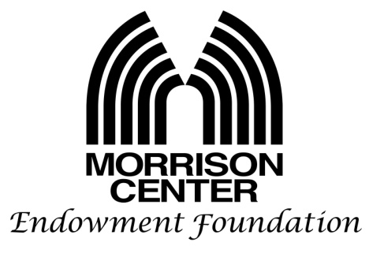

Application date: __________________________
Grant applications are due January 1 and July 1 of each year

Section 1.
Information about Your Group
(Only fill out one per grant cycle.)

Name of organization: _______________________________________________________________________________
Address of organization: _____________________________________________________________________________
I.R.S. identification number (also attach copy of Section 501 exemption letter):__________________________________
Grant Writer: _____________________________________Email: _____________________ Telephone: ____________
Organization Executive: ____________________________Email: ______________________Telephone: ____________
Name & address of the principal officers, directors or trustees:
__________________________________________________________________________________________________
__________________________________________________________________________________________________
__________________________________________________________________________________________________
__________________________________________________________________________________________________
__________________________________________________________________________________________________
Have we contributed to your organization before? __________ If yes, when was the last time?______________________

Section 2
Performance Application
(Fill out one per show.)

Application date: __________________________
Title of show: ________________________________________________________________________________
Date(s) of show: ______________________________________________________________________________
Brief description of show: _______________________________________________________________________
__________________________________________________________________________________________________
__________________________________________________________________________________________________
__________________________________________________________________________________________________
__________________________________________________________________________________________________
Briefly elaborate on why the Endowment should fund this show (how does it benefit the community)? __________________________________________________________________________________________________
__________________________________________________________________________________________________
__________________________________________________________________________________________________
__________________________________________________________________________________________________
__________________________________________________________________________________________________
Is this a new use for the Morrison Center? Yes or No.
Are you bringing in outside performers? If yes, who? _______________________________________________________
What will be the audience ticket price range? _____________
What is your projected revenue from ticket sales? _________________
Do you plan to discount ticket prices if we subsidized this performance? Yes or No.
Are you applying to other funding sources?______ If yes, please list showing requested amount:
__________________________________________________________________________________________________
__________________________________________________________________________________________________
__________________________________________________________________________________________________
__________________________________________________________________________________________________
Estimated cost of performance (attach a detailed budget with your projected revenue and shortfall)? _________________
What is the amount of funding requested from the Morrison Center Endowment Foundation?_______________________

